A
REAL TIME PROJECT
on

AUTOMATIC DOOR BELL RINGER USING 555 TIMER
Submitted in partial fulfilment of the Requirements for the award of Degree
Of Bachelor of Technology in
ELECTRONICS &COMMUNICATION ENGINEERING
BY
M.SHAILAJA (23681A0417)
B.VAISHNAVI (24685A0401)
N.SWETHA (24685A0417)
M.RAJESH (23681A0418)
Under the gudience of

Mr.K.AMARENDER
M.TECH Assistant professor

CHRISTU JYOTHI INSTITUTE OF TECHNOLOGY AND SCIENCE
ColomboNagar, Yeshwanthpur, Jangaon, TS 506167, Telangana
Department of Electronics &Communication Engineering
(Accredited by National Board of Accreditation)
2024-2025
CHRISTU JYOTHI INSTITUTE OF TECHNOLOGY & SCIENCE
(Affiliated to JNTU, Hyderabad)
Colombonagar, Yeshwanthapur, Jangaon Dist. 506167, Telangana
Dept. Electronics & Communication Engineering

CERTIFICATE
This is to certify that the work which is being presented in the B. Tech. Mini Project Report
entitled “AUTOMATIC DOOR BELL RINGER USING 555 TIMER”being submitted by

M.SHAILAJA(23681A0417),B.VAISHNAVI(24685A0401),N.SWETHA(24685A0417),
M.RAJESH(23681A0418) impartialfulfillment ofthe requirementsfor the award of the Bachelor of Technology in “Electronics &Communication Engineering “and submitted to the Department of Electronics & Communication Engineering of Christu Jyothi InTechnology and Science, Jangaon.
This is to certify that the above statement made by the candidate is correct to the best of my knowledge
SIGNATURE OF GUIDE SIGNATURE OF HOD
MR. K.AMARENDER MR. ALLANKI SANYASI RAO
ASSISTANT PROFESSOR ASSOCIATE PROFESSOR
CHRISTU JYOTHI INSTITUTE OF TECHNOLOGY & SCIENCE
(Affiliated to JNTU, Hyderabad)
Colombonagar, YeshwanthapurJangaonDist

Institute Vision and MissionVision

To admit and groom students from rural background and be a truly rural technical institution, benefiting society and nation as a whole institute.
- Mission
- The mission of the institution is to create, deliver and refine knowledge. Being a rural technical institute, our mission is to.
- Enhance our position to one of the best technical institutions and to measure our performance against the highest defined standards.
- Provide highest quality learning environment to our students for their greater well-being so as to equip them with highest technical and professional ethics.
- Produce engineering graduates fully equipped to meet the ever-growing needs of industry and society

PRINCIPLE
CHRISTU JYOTHI INSTITUTE OF TECHNOLOGY & SCIENCE
(Affiliated to JNTU, Hyderabad)

Department of electronics and communication engineering

VISION
To be an established center of excellence in Electronics and Communication Engineering facilitating youth towards professional, leadership and industrial needs.

MISSION
- Impart theoretical and practical technical education of high standard with quality resources and collaborations.
- Organize trainings and activities towards Overall personality development in time with industrial need.
- Promote innovation towards sustainable solutions with multi discipline team workwith ethics.

HEAD OF THE DEPARTMENT

DECLARATION

We hereby declare that the project entitled--" AUTOMATIC DOOR BELL RINGER USING 555 TIMER", which us being submitted as Mini Project in Electronics and Communication Engineering TO CHRISTU JYOTHI INSTITUTE OF TECHNOLOGY & SCIENCE, is an authentic record of my genuine work done under the guidance of K.AMARENDER, Assistant Professor of ECE Dept.

BY
M.SHAILAJA (23681A0417)
B.VAISHNAVI (24685A0401)
N.SWETHA (24685A0417)
M.RAJESH (23681A0418)

ACKNOWLEDGMENT

- We here by express our sincere gratitude to the Management ofChristu Jyothi Institute of Technology & Science for their kind encouragement bestowed up on us to do this project.
- We earnestly take the responsibility to acknowledge the following distinguished personalities who graciously allowed our project work successfully.
- We express our sincere thanks to the Director Rev.Fr. D. Vijaya Paul Reddy, Principal Dr. S. Chandrasekhar Reddy for their encouragement, which has motivated us to strive hard to excel in our discipline of engineering.
- We express our profound sense of appreciation and gratitude to our principal and project guide K.Amarender,Associate Professor for providing generous assistance, and spending many hours of valuable time with us. This excellent guidance and support have made the timely completion of this project.
- We greatly indebted to the Head of the Department Mr.AllankiSanyasiRao, Assistant Professor for her motivation and guidance through the course of this project work. She has been responsible for providing us with a lot of splendid opportunities, which has shaped our career. His advice ideas and constant support has engaged us on and helped us to get through in difficult time.
- Our heartfelt thanks to Project Coordinator, K.Chiranjeevi, Assistant Professor for the support and advice they have given us through our project reviews. We also wish to thank them for their guidance and support during our early days in the area of automation.
- Last but not least we express our gratitude to the faculty and lab technicians of Department of Electrical and Electronics Engineering for their needy and continuous support in technical assistance.

Project Associates:
M.SHAILAJA (23681A0417)
B.VAISHNAVI (24685A0401)
N.SWETHA (24685A0417)
M.RAJESH (23681A0418)

ABSTRACT

This project presents the design and implementation of an Automatic Door Bell Ringer using the popular 555 timer IC in monostable mode. The system is designed to simplify the doorbell operation by producing a predefined ringing duration with a single press of a button. When the push button is pressed, the 555 timer is triggered, generating a high output for a fixed time interval, during which the bell or buzzer rings. This eliminates the need for manual control of ringing duration, ensuring consistent and efficient operation. The design is cost-effective, easy to build, and ideal for educational and home automation applications.

The Automatic Door Bell Ringer using a 555 Timer is a simple yet effective electronic project designed to automate and regulate the operation of a doorbell. Traditional doorbells depend entirely on the duration for which the push button is pressed, which can lead to unnecessarily long or short rings. This project utilizes the versatile 555 timer IC in monostable mode to produce a fixed-duration output pulse that activates the bell or buzzer for a consistent time period, regardless of how long the button is pressed.
When a visitor presses the doorbell switch, the 555 timer is triggered through a negative edge signal. The timer then produces a high output for a specific duration, which is determined by an external resistor (R) and capacitor (C) connected to the timer. This output activates a relay or directly powers a bell/buzzer to produce a sound. After the set time elapses, the output returns to low, turning off the bell automatically.
This circuit is highly reliable, cost-effective, and easy to construct using basic electronic components. It finds applications not only in residential buildings but also in small offices, schools, and similar facilities. The project serves as an excellent introduction to timer-based circuits and automation principles in electronics.

CONTENTS

1. Introduction
2. Infrared (IR) sensor or photodiode
3. Resistors(1K,10K,4.7K)
4. Capacitors(10mf)
5. Buzzer
6. Battery (9V)
7.Bread board
8.Transistor(NPN)

LIST OF FIGURES

1). Automatic door bell ringer
2).Circuit diagram
3).9V Battery
4).Infrared sensor
5).Bread board
6).Buzzer
7).Resistors (1k,4.7k,10k)
8).capacitors (10mf)
9).photo diodes (2)
10).Transistor (NPN)
11). Connecting wires

INTRODUCTION
Automation has become an integral part of modern life, significantly transforming how we interact with technology in our homes, workplaces, and public environments. As the demand for smart and responsive systems increases, there is a growing interest in automating even the simplest of daily tasks to improve convenience, security, and efficiency. One such area that has seen notable development is home automation, which includes systems such as lighting control, climate management, security monitoring, and automated door access systems.
Among the various components of home automation, the Automatic Door Bell Ringer presents a practical and innovative solution to improve visitor notification mechanisms. Traditionally, doorbells require a visitor to press a button manually, which then alerts the people inside the building. However, this conventional approach has certain limitations—visitors may be unaware of how to operate the doorbell, it may malfunction, or the system may be inaccessible for children, the elderly, or individuals with disabilities. Additionally, in high-traffic areas or during working hours, occupants may not always be near the door to hear or respond to a visitor.
The Automatic Door Bell Ringer addresses these issues by employing sensor-based or wireless technologies to detect a visitor's presence and automatically trigger the bell without any physical interaction. Typically, components such as infrared (IR) sensors, ultrasonic sensors, motion detectors, or even cameras with AI integration can be used to detect movement or body heat near the door. Once a presence is detected, the system activates an alert mechanism, such as ringing a bell or sending a notification to a smartphone or intercom system. This ensures timely and efficient communication between the visitor and the host, reducing the chances of missed visitors and enhancing overall home security.
This project is particularly beneficial in settings where frequent visitors are expected, such as in offices, institutions, or houses with elderly occupants who may have difficulty reaching the door quickly. Moreover, the system can beexpanded with additional features such as night vision, face recognition, orremote access control to further increase its utility and sophistication.
In this project, we aim to design and implement a simple yet effective automatic door bell ringer system using affordable and readily available electronic components. The system will be programmed to detect the presence of a person near the entrance and respond accordingly by activating the bell. Our design will emphasize energy efficiency, reliability, and ease of use, with a focus on ensuring the system is both cost-effective and scalable for real-world applications

Description
The Automatic Door Bell Ringer is an intelligent system designed to automatically detect the presence of a person at the entrance and activate a doorbell without requiring any physical contact. Unlike conventional doorbells that depend on the manual pressing of a button, this system operates based on sensor input, making it a more user-friendly, hygienic, and accessible solution.
At the heart of the system is a motion detection sensor—commonly an Infrared (IR) sensor, PIR (Passive Infrared) sensor, or Ultrasonic sensor—which continuously monitors the area near the door. When a person approaches and enters the sensor’s detection range, it senses the motion or heat signature and sends a signal to a control circuit. This signal is then processed by a microcontroller or relay-based switching mechanism that triggers the ringing of the bell.
This system offers several advantages. Firstly, it improves convenience, especially in scenarios where the visitor may not know where the doorbell is located or may be unable to reach it. Secondly, it improves accessibility for the elderly, children, or physically challenged individuals who may find it difficult to press a doorbell. Thirdly, it enhances security, as it ensures that any motion near the entrance is detected and logged (if extended with surveillance or alert systems). The system can also be expanded to include features like automatic lighting, camera activation, or wireless notifications for smart home integration.
The overall setup is simple and cost-effective. The components used—such as sensors, microcontrollers (like Arduino), buzzers, power supplies, and possibly wireless modules—are readily available and easy to assemble. The system is also energy-efficient, as it only activates the bell when someone is present, minimizing unnecessary power usage.
In this project, the goal is to design and implement a functional Automatic Door Bell Ringer that demonstrates the concept of sensor-based automation. The circuit will be tested to ensure reliable detection, quick response time, and stable operation under various conditions. This project not only demonstrates practical electronics and automation but also reflects the growing trend toward smart home technologies.

LIST OF SYMBOLS AND ITS OPERATION:

1kΩ Resistor:
A 1kΩ resistor is an electronic component that provides a resistance of 1,000 ohms to the flow of electric current. It is widely used in electronic circuits to control or limit the current, protect sensitive components, and divide voltages. The resistor is a passive component and follows Ohm’s Law (V = IR). In many circuits, a 1kΩ resistor is used in series with LEDs to prevent them from burning out due to excess current. It is also commonly used in timing circuits, sensor interfacing, and logic gates for pull-up or pull-down purposes. The standard symbol for a resistor in a circuit diagram is a zigzag line (U.S. style: /\/\/) or a rectangle (European style: [ ]). The resistor with a value of 1kΩ typically has a color code of Brown, Black, Red, and Gold, where brown represents 1, black represents 0, and red is the multiplier (×100), giving a total resistance of 1,000 ohms. The gold band indicates a tolerance of ±5%. The 1kΩ resistor is a basic yet essential component in both analog and digital electronics.

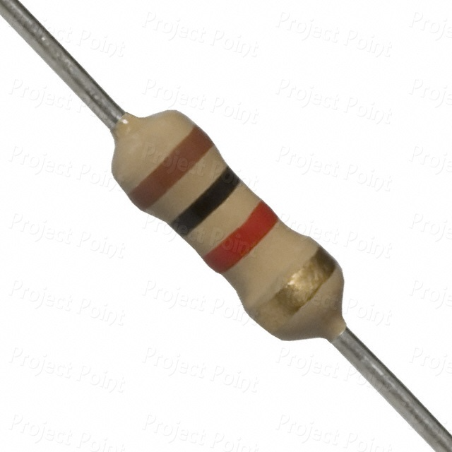

4.7kΩ Resistor :
A 4.7kΩ resistor is a passive electronic component that offers a resistance of 4,700 ohms (4.7 kilo-ohms). It is commonly used in various electronic circuits to limit current, divide voltage, and bias active components like transistors and operational amplifiers. The resistor works according to Ohm’s Law (V = IR), and its main role is to control the flow of electric current, ensuring that sensitive components are not damaged by excessive current. A 4.7kΩ resistor is especially useful in signal processing, sensor circuits, pull-up/pull-down configurations in digital logic, and filtering applications. The color code for a 4.7kΩ resistor is Yellow, Violet, Red, Gold, where yellow represents 4, violet represents 7, and red is the multiplier (×100), resulting in 4,700 ohms. The gold band indicates a tolerance of ±5%

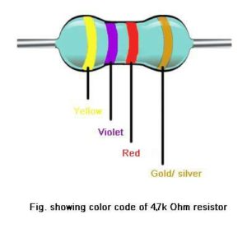
10kΩ Resistor:
A 10kΩ resistor is a passive electronic component that provides a resistance of 10,000 ohms (10 kilo-ohms). It is one of the most commonly used resistor values in electronic circuits due to its versatility and balanced resistance level. The main function of a 10kΩ resistor is to limit the flow of electric current, divide voltage, or bias electronic components such as transistors and op-amps.

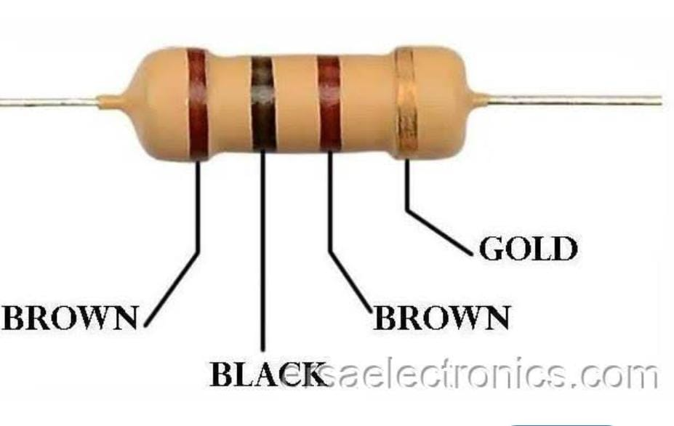

10µF Capacitor:
A 10µF capacitor is a passive electronic component that stores and releases electrical energy in a circuit. The unit “µF” stands for microfarads, and a 10µF capacitor has a capacitance of 10 microfarads, meaning it can store a moderate amount of electric charge. Capacitors are widely used for filtering, timing, smoothing voltage, and energy storage in both analog and digital circuits. A 10µF capacitor is commonly found in power supply circuits where it helps smooth out voltage fluctuations and reduce noise. It is also used in RC timing circuits, audio applications, and coupling or decoupling signals.

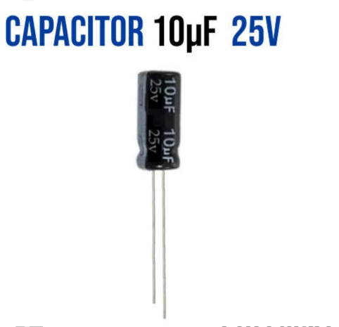

CIRCUIT DIAGRAM:

The circuit diagram of the Automatic Door Bell Ringer using a 555 Timer showcases a simple and efficient design that triggers a buzzer when a person is detected at the door. At the heart of the circuit is the NE555 timer IC, configured in monostable mode, meaning it generates a single output pulse of a fixed duration when triggered.
In the diagram, the sensor (such as an IR sensor or photodiode) is connected to Pin 2 (Trigger) of the 555 timer. When the sensor detects motion, it sends a low voltage signal to this pin, which causes the output at Pin 3 to go high. This high output activates the buzzer, which alerts the homeowner.

9V Battery:
A 9V battery is a compact, rectangular-shaped power source commonly used in electronic circuits, portable devices, and DIY projects. It provides a voltage of 9 volts and typically has a snap connector with a positive and negative terminal on the top. This type of battery is often used in small electronics such as smoke detectors, handheld meters, toys, and beginner-level electronic kits. Inside, it usually contains six 1.5V cells connected in series. The 9V battery comes in different types including alkaline, rechargeable (NiMH or Li-ion), and carbon-zinc, with alkaline being the most common for general use



Photodiodes:
A photodiode is a type of semiconductor device that converts light into electrical current. It operates in reverse bias, meaning the voltage is applied in the opposite direction to conventional current flow. When light photons strike the photodiode’s junction, they generate electron-hole pairs, which create a current proportional to the intensity of the light. Photodiodes are highly sensitive to changes in light and are commonly used in light detection applications such as optical sensors, infrared detectors, remote control systems, and safety devices.

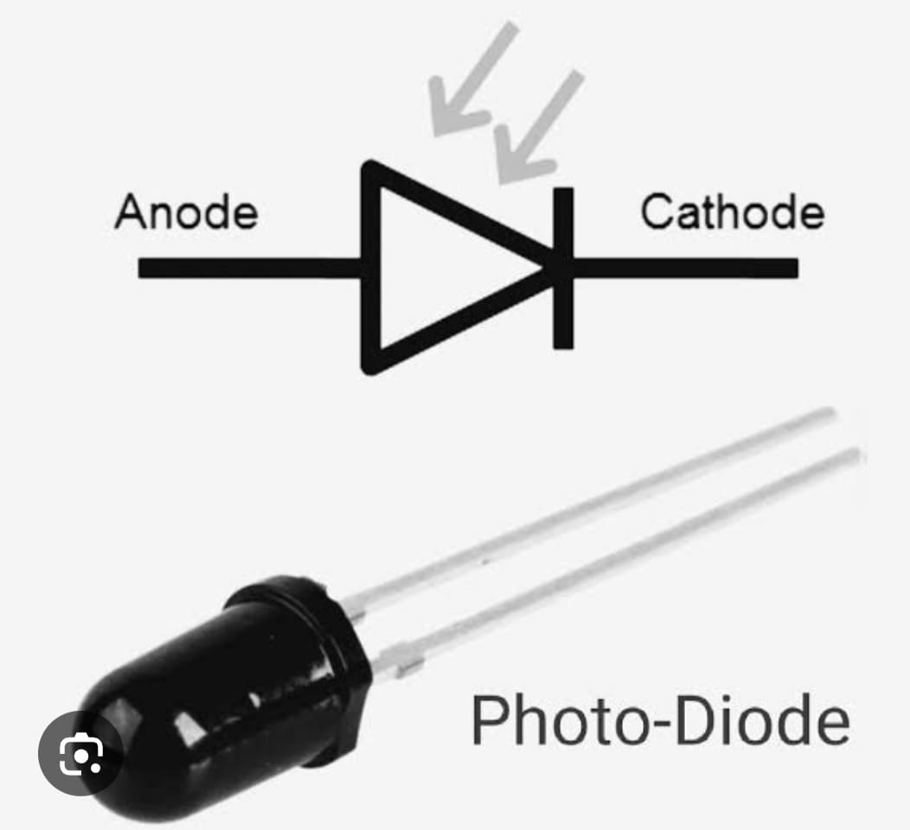
Buzzer:
A buzzer is an audio signaling device commonly used in electronic circuits to produce sound or alert signals. It converts electrical energy into sound energy, usually in the form of a beep, tone, or alarm. Buzzers are available in two main types: active and passive. An active buzzer has a built-in oscillator and only requires a DC voltage to operate, whereas a passive buzzer needs an external oscillating signal (like from a microcontroller) to produce sound. Buzzers are widely used in applications such as door bells, timers, alarms, toys, and electronic notifications.

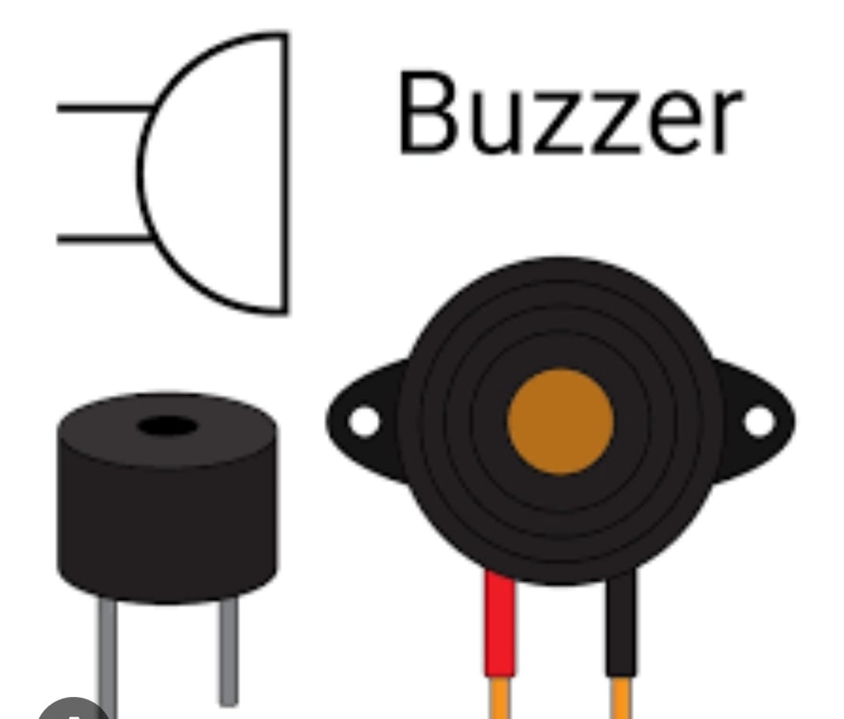

NPN Transistor:
An NPN transistor is a type of bipolar junction transistor (BJT) used to amplify or switch electronic signals. It consists of three layers of semiconductor material arranged as Negative-Positive-Negative (N-P-N) and has three terminals: Emitter (E), Base (B), and Collector (C). In an NPN transistor, a small current entering the base allows a much larger current to flow from the collector to the emitter. This makes it useful for amplifying signals or acting as an electronic switch in circuits. NPN transistors are commonly used in digital logic circuits, audio amplifiers, motor drivers, and many control systems.

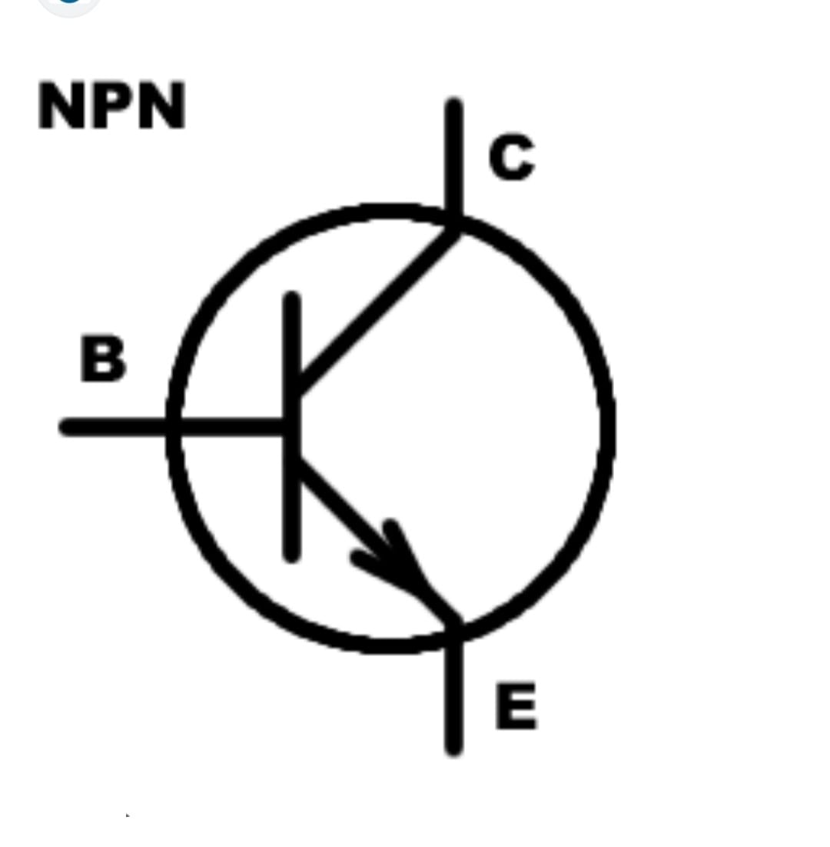

Breadboard:
A breadboard is a reusable platform used for building and testing electronic circuits without the need for soldering. It allows components like resistors, capacitors, transistors, ICs, and wires to be easily inserted and connected to form a circuit. The breadboard consists of a grid of holes arranged in rows and columns, with metal strips underneath to provide electrical connections.

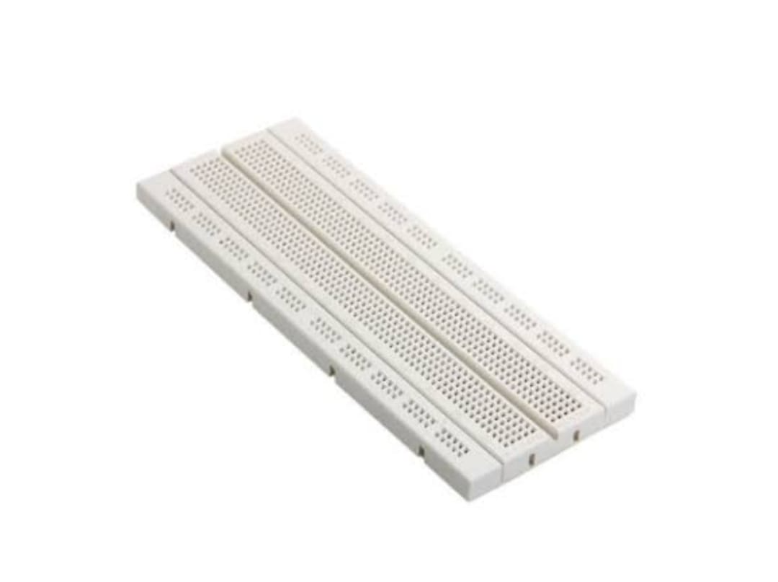

Future Scope:
The Automatic Door Bell Ringer project, while simple and functional, offers several possibilities for future development and enhancement. In the future, the system can be upgraded by integrating wireless communication modules such as Wi-Fi or Bluetooth, allowing users to receive notifications or control the system via a smartphone app. Adding a camera module or face recognition system could enhance security by visually identifying visitors. The use of microcontrollers like Arduino or Raspberry Pi can enable advanced automation features, such as logging visit times or triggering different actions based on the time of day. The system can also be connected to home automation platforms like Alexa or Google Home for seamless integration with smart home environments. Additionally, using solar panels for power supply could make the system more energy-efficient and eco-friendly. These improvements would make the system not just a doorbell but a complete smart entry management solution.
The Automatic Door Bell Ringer project demonstrates a basic application of sensor-based automation in everyday life. While the current version performs its intended function effectively—automatically ringing a bell when a person is detected at the door—it also opens up a wide range of possibilities for further enhancement, integration, and real-world application in more advanced systems.

Conclusion:
The Automatic Door Bell Ringer project successfully demonstrates how basic electronic components can be combined to create a functional and efficient automation system for real-life applications. By utilizing sensors such as motion detectors or infrared sensors, the system is able to detect the presence of a visitor and automatically trigger a buzzer or bell without requiring any manual input. This makes the system more convenient, user-friendly, and accessible—particularly for the elderly, physically challenged, or in situations where traditional doorbells are impractical.
Throughout the development of this project, we gained valuable hands-on experience in working with essential electronic components like resistors, capacitors, transistors, buzzers, and sensors. We also learned how to design and test circuits on a breadboard and troubleshoot common issues, which enhanced our understanding of how real-world electronic systems are built and maintained.
The project achieved its primary objective of automating the doorbell mechanism and demonstrated reliable performance under typical conditions. Furthermore, this project lays the groundwork for more advanced implementations. With future improvements such as wireless communication, camera integration, and smart home compatibility, the system could be transformed into a comprehensive smart door monitoring solution.
In conclusion, this project not only serves as a successful example of basic automation but also highlights the importance of innovation and practical thinking in solving everyday problems through electronics.

References:

Online Resources
1. Electronics Tutorials: Websites like Electronics Tutorials, All About Circuits, or Instructables often have projects and tutorials on 555 timer applications.
2. YouTube Channels: Channels like Electronics Project, DIY Projects, or 555 Timer Projects may have video tutorials and explanations.
Books
1. "The 555 Timer Applications Sourcebook" by Howard M. Berlin
2. "Electronic Projects for Beginners" by A. K. Maini
3. "555 Timer IC Circuits" by Owen Bishop
Research Papers
1. IEEE Xplore: Search for papers on doorbell systems or 555 timer applications.
2. ResearchGate: Look for publications on automatic doorbell systems or related topics.
Projects
1. Automatic Doorbell Circuit using 555 Timer (Electronics Tutorials)
2. Doorbell Circuit using 555 Timer (DIY Projects)
3. Smart Doorbell System using 555 Timer (ResearchGate)

APPENDICES:
Appendix A: Component List
Component | Value/Type | Description
555 Timer IC | NE555 | Used for generating timing pulses.
Resistor (R1) | 10kΩ | Current-limiting resistor.
Capacitor (C1) | 10µF | Sets timing for the monostable operation.
Buzzer | 9V Buzzer | Used to emit a sound when triggered.
Photodiode/IR Sensor | - | Detects motion or presence.
Battery | 9V | Provides power to the circuit.
Breadboard | - | Platform for assembling the circuit.
Jumper Wires | - | Connects components on the breadboard.

Appendix B: Working Principle
The Automatic Door Bell Ringer project functions by utilizing the 555 timer IC, along with other basic electronic components, to detect a visitor at the door and activate a buzzer to alert the homeowner. The circuit is designed to work in monostable mode, which means that the 555 timer generates a single pulse of a fixed duration when triggered.

Appendix C: Testing Procedure
The Automatic Door Bell Ringer project can be tested through several steps to ensure it functions correctly and meets its intended objectives. Below is a structured testing procedure to verify the proper operation of the system.

Appendix D: Safety Precautions
When working with electronic circuits, especially those involving power sources, active components, and testing processes, safety is paramount. The following safety precautions should be observed to ensure the safety of both the user and the components during the Automatic Door Bell Ringer project.

Appendix E: Challenges Faced
During the design, assembly, and testing phases of the Automatic Door Bell Ringer using a 555 Timer, several challenges were encountered. These challenges are part of the learning process and offer insights into troubleshooting and improving the overall system. Below are some of the key challenges faced during the project:

Appendix F: Cost Estimation
Components Cost Breakdown:
Component | Estimated Cost (in USD) | Notes
555 Timer IC (NE555) | $0.50 | A commonly used timer IC for various applications.
IR Sensor / Photodiode | $2.00 | For detecting the presence of a person.
Buzzer (Active/Passive) | $1.50 | Active buzzers are commonly used for alarms.
Resistors (e.g., 1kΩ, 4.7kΩ, 10kΩ) | $0.20 | Cost for a pack of various resistors.
Capacitors (10µF, etc.) | $0.30 | Cost for a pack of capacitors.
Breadboard | $5.00 | A standard 830-point breadboard for testing circuits.
Jumper Wires | $2.50 | A set of jumper wires to connect components on the breadboard.
9V Battery | $1.50 | Standard 9V battery for powering the circuit.
Transistor (NPN) | $0.20 | Used for switching the buzzer if needed.
Diode | $0.10 | To protect the circuit from potential back EMF.

Appendix G: Future Improvements
While the current version of the Automatic Door Bell Ringer using a 555 Timer functions effectively for its intended purpose, there are several ways in which the system can be upgraded or enhanced in future iterations. These improvements would increase its functionality, efficiency, reliability, and adaptability to real-world scenarios.

